Foods 9/10
Revised 2016
Naan Bread
(Serves 2-3; 2 recipes per unit)
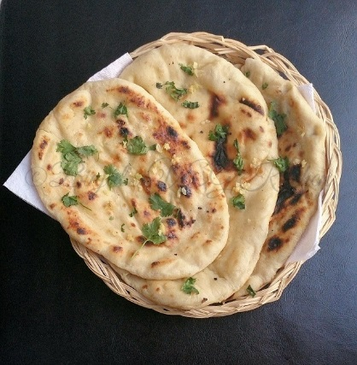
Day 1:
Ingredients:
325 mL flour
4 mL instant yeast
1 mL salt
15 mL oil
65 mL buttermilk
warm water

Method:
- In a large bowl, mix flour, yeast and salt.
- Add oil and mix well with a wooden spoon.
- Gradually add buttermilk; mix to make a soft dough, adding warm water if necessary. Dough should be soft but not sticky (should feel similar to gently pressing your finger in to your cheek).
- Knead dough on a lightly floured surface until smooth and elastic.
- Place in lightly oiled plastic bag, making sure dough is covered with oil.
- Label and refrigerate.
Day 2:
- Divide dough into 4 pieces.
- Shape each piece into a 3-inch/15 cm round/oval shape, about ½-cm thick. Traditional naan bread is baked in the shape of a “slipper.”
- Preheat broiler for 1-2 minutes, making sure oven rack is in top position.
- Place pieces on a cooling rack, then place the cooling rack on a cookie sheet pan.
- Broil until light brown, turning once (approx. 2 minutes per side)
- Serve with a favourite condiment, such as raita.
