Foods 9-10(A)
Vint – Revised 2017
CHOCOLATE CHIP BISCOTTI
One recipe per 2-3 people (max 2 per unit)
Makes 10-12 biscotti per recipe

“Biscotti” are Italian cookies (or biscuits). Almonds are commonly used (whole nuts and/or in extract form) but the variety of possible flavours is impressive. The defining characteristic of biscotti is that they are “twice-baked,” which results in a very crispy treat that is perfect for dunking in milk, coffee or tea. The dough is formed in to a loaf and then baked. After baking and cooling, the loaf is sliced into individual, oblong-shaped cookies. These slices are then laid flat on a baking sheet/pan and baked again until they are dry and crisp.
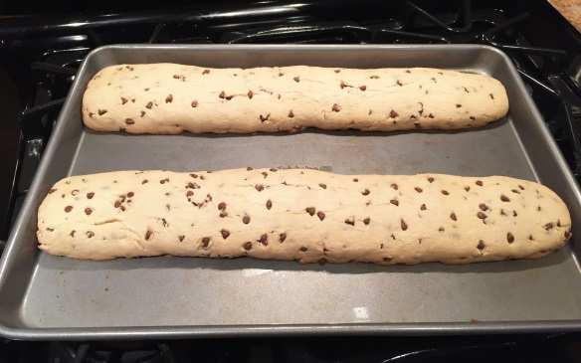
250 mL all-purpose flour
80 mL sugar
3 mL baking soda
1 mL salt
60 mL chocolate chips
2 med eggs, beaten
3 mL vanilla

Day 1 – Make dough and first baking.
- Pre-heat oven to 350ºF with rack in the centre position. Grease a baking pan with shortening.
- In a medium mixing bowl, combine flour, sugar, baking soda, salt and chocolate chips.
- Stir vanilla into beaten eggs. Add this to the flour mixture and stir until blended and soft dough forms.
- Place dough on a CLEAN, lightly floured surface and knead dough 8-10 times.
- Form dough into a log about 2” (5 cm) x 8” (20 cm) and place on greased baking pan.
- Bake at 350ºF for about 30-35 minutes, or until the edges are golden brown.
- Allow loaf to cool completely to room temperature, then wrap and label for the second baking next class.

Day 2 – Slice and bake a second time.
- Pre-heat oven to 325ºF with rack in the centre position. Grease a baking pan.
- Using a cutting board and a bread knife (in a sawing motion), carefully slice biscotti loaf diagonally into uniform slices, about 1½ cm (5/8”) each.
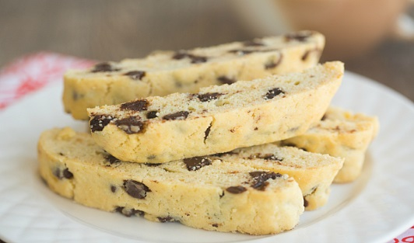
- Lay biscotti slices flat on baking pan, cut side up. Bake for about 7-8 minutes, then turn the slices over and bake for another 7-8 minutes or until they are beginning to turn golden brown on the edges. Centres should still be slightly soft, but they will harden as they cool.

