Foods 9-10(A)
FETTUCINE PASTA
One recipe per unit of 4-5 people.
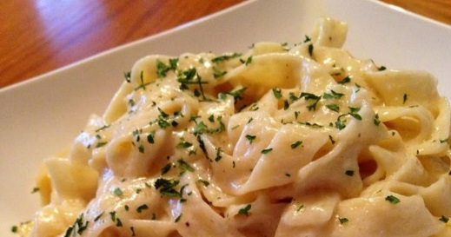
DAY 1 – Make pasta dough

350 mL all-purpose flour
3 eggs, medium or large size
½ mL salt

- Place flour on a clean surface, such as a counter or pastry board. Make a well in the centre.
- Add the eggs and salt to the well in the centre of the flour. Beat the eggs lightly with a fork.
- Starting from the inside edge of the flour well, gradually incorporate the flour into the eggs, just until soft dough forms.
- Knead the dough for about 10 minutes, sprinkling with a little extra flour ONLY IF the dough is sticking to the counter.
- NOTE: Be very careful not to add TOO MUCH flour while kneading or your dough will become very stiff and dry. If this happens, the dough will be very difficult to roll out by hand and it will be unsuitable to use with a pasta machine.
- Wrap dough tightly in plastic wrap and place in a labelled zipper freezer bag to be refrigerated for next class.
- NOTE: At home, wrap dough and let rest for 20 minutes on counter before rolling out and cooking.

DAY 2 – Make sauce; roll, cut and cook noodles

Rolling and cutting noodles by hand:

- Shape dough into a rectangle about 1½ cm / 1” thick. Dust lightly with flour. With a rolling pin, roll out dough into a thin rectangle. Rotate the dough often and dust lightly with flour, if necessary, to prevent sticking. Dough should be almost paper thin (thin enough to just see the board or counter through it).
- Sprinkle dough lightly with flour and roll loosely, starting at the long side of the rectangle. Transfer the roll to a cutting board. With a very sharp knife, carefully slice the roll into even ½-cm-wide strips. Unroll the strips to make long fettucine noodles. To prevent noodles from sticking to each other, sprinkle the noodles lightly with flour and toss gently to coat.

Rolling and cutting noodles using a pasta machine:

- Follow the instructions given for the pasta machine and during the demonstration. To prevent noodles from sticking to each other, sprinkle the noodles lightly with flour and toss gently to coat.

To Cook & Serve Fresh Pasta noodles:

- Fill a large pot ¾ full with water and bring to a boil on high heat. Add 1 mL salt to boiling water. Optional – add 5 mL oil. Add the fettucine noodles to the boiling water. When the water returns to a full, rolling boil, reduce heat to medium-high and cook noodles until al dente (JUST tender to the bite), about 2-5 minutes, depending on thickness of noodles. Taste to test for doneness.
- Remove noodles with tongs to a colander placed inside a large mixing bowl. Alternatively, if no more noodles are to be cooked, drain directly into the colander placed an empty sink. Serve with sauce.

ALFREDO SAUCE
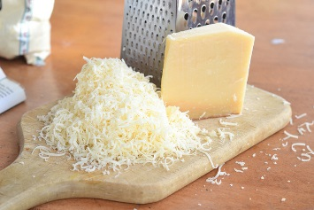
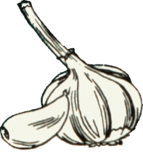
Ingredients
25 mL | 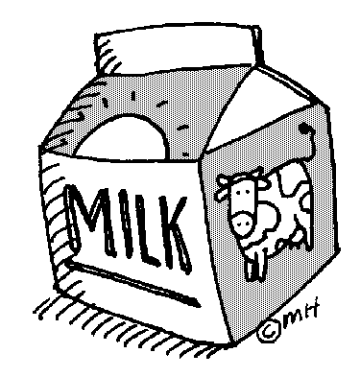  margarine
1 large | clove garlic, minced
25 mL | flour
250 mL | milk, preferably 3.25% MF, or whole/homogenized milk
50 mL | Parmesan cheese
To taste | Salt & ground black pepper
To garnish | parsley, chopped

- Melt margarine in a small saucepan (pot), over medium-low heat (#3-4 on school stoves). Add minced garlic and sauté just until golden (1-2 minutes).
- Stir in flour and cook, stirring, until smooth (another 1-2 minutes).
- Using a rubber spatula, stir in milk GRADUALLY to prevent lumps from forming.
- Continue cooking, slowly scraping the bottom of the pot with the rubber spatula to prevent mixture from burning or sticking, until the sauce begins to bubble. Continue cooking and slowly scraping the bottom of the pot until the mixture has simmered (slowly bubbling) for 2-3 minutes. Sauce should be thickened but should still run off the spatula in a thick stream. It should NOT become gel-like in texture.
- Add salt, pepper and cheese. Stir to combine.
- Toss with drained, cooked pasta and transfer to plates. Sprinkle each plate with chopped parsley and serve hot.
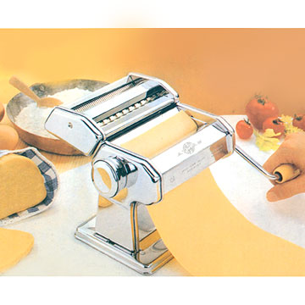
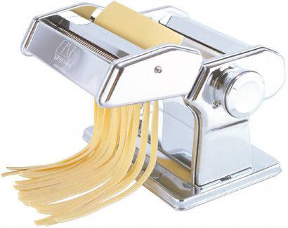

Revised 2017 Vint

