**EASY RISOTTO**

One recipe per 2-3 people

Risotto is a classic Italian dish in which Arborio rice is first browned and then simmered in broth. The finished product has a creamy consistency and a tender but slightly firm texture. In this simplified version, the constant stirring required by the classic recipe is eliminated.

C:\Users\Vint\AppData\Local\Microsoft\Windows\Temporary Internet Files\Content.IE5\H2GF2FA4\MC900331375[1].wmf

15 mL margarine, butter, olive oil or cooking oil

¼ sm-med cooking onion, minced

3 medium mushrooms, finely chopped

1 slice Prosciutto ham, finely chopped

1 medium clove garlic, minced

125 mL Arborio rice (any short grain white rice will do)

375 mL hot water (heat to just below boiling in microwave)

15 mL instant chicken or vegetable bouillon powder

f.g. black or white pepper

25 mL Parmesan or Romano cheese (freshly grated is best)

5 mL (approx.) extra cheese to sprinkle on top before serving

1. Heat oil in a small saucepan (a pot) on medium-low heat (about #3-4). Sauté onions, mushrooms and Prosciutto in the oil for about 3 minutes or until onions just begin to soften.
2. Add garlic and uncooked rice to the onion mixture. Stir to coat rice with oil. Cook and stir for 2-3 minutes more. Rice may begin to turn a pale golden colour. Do not overcook garlic or it will become bitter.
3. Stir bouillon and pepper into the hot water then stir this bouillon mixture in to the rice. Turn heat to high and bring to a boil. Stir once or twice during heating.
4. Once the rice mixture has reached boiling, stir, cover the pot with a tight-fitting lid and reduce heat to low-simmer, so you can just barely see a small amount of steam escaping under the lid.
5. Simmer for 20 minutes. Use a timer and do not lift the lid!
6. After 20 minutes, remove the saucepan from the element (leave the lid on) and let stand on a cool element or wire rack for 5 minutes.
7. After the rice stands for 5 minutes, remove lid and stir to check that rice is cooked (tender but slightly firm) and that the consistency is creamy. If rice is dry, stir in a little cool water to reach a creamy consistency.
8. Stir in cheese. Place on plates for serving and sprinkle a little extra cheese on each.

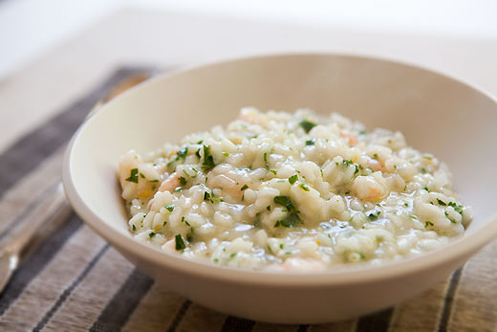

Foods 9-10(A) Vint 2106