Foods 9/10(A)
TORTUFO – Italian Frozen Mousse (Foam)
Serves 4-5 (one recipe per unit)

Serves 4 |  | Serves 5
30 mL | egg white | 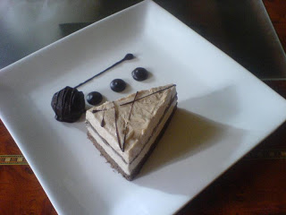  40 mL
3 mL | instant coffee powder | 4-5 mL
5 mL | cocoa powder | 7 mL
f.g. (pinch) | salt | f.g. (pinch)
15 mL | sugar | 20-25 mL
--------- | ----------------------------- | ---------
125 mL | whipping cream | 150 mL
30 mL | sugar | 40 mL
2 mL | vanilla | 3 mL

*NOTES:
- The small mixing bowl and beaters that will contact the unbeaten egg whites must be thoroughly washed with hot, soapy water & rinsed before use. Any fat present (such as egg yolk or grease) will prevent the foam from gaining full volume.
- You will achieve the best volume from your foams if egg whites are room temperature and whipping cream is cold.

- Line muffin pan with 4 or 5 paper liners.

- In a CLEAN, small mixing bowl and with CLEAN beaters, beat egg white at high speed with an electric mixer until just shiny and stiff peaks hold their shape. Stiffly beaten egg whites should not slide around in the bowl. Do not over-beat or egg whites will become dull and dry and they will not hold air.

- In a custard cup, combine coffee powder, cocoa, salt and first amount of sugar in ingredient list (15 mL for 4 servings OR 20-25 mL for 5 servings).
Stir in 10-15 mL of the whipping cream and mix to form a paste.

- Gently fold the coffee mixture in to the beaten egg white.

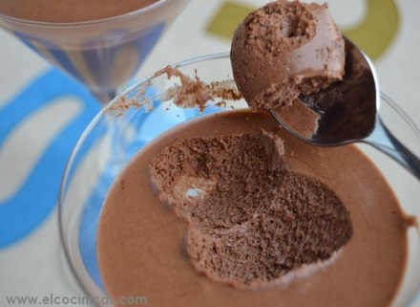
- Meanwhile, in a separate (medium) bowl, whip the remaining whipping cream. When cream begins to thicken slightly, add the vanilla and gradually beat in the remaining 30/40 mL of sugar. Beat until peaks hold. It should look similar to the egg whites. Do not over-beat cream or you will make butter.

- Fold the egg white mixture into the whipped cream.

- Spoon equally into the prepared muffin cups.

- Cover tightly with plastic wrap, label and freeze.

- Sift a little cocoa powder over the top when serving.

Vint 2016

