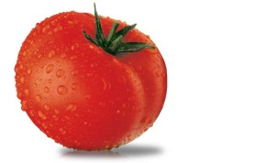
TOMATO AND FRESH BASIL SOUP
Makes 2-3 servings or One recipe per unit for sharing lab.
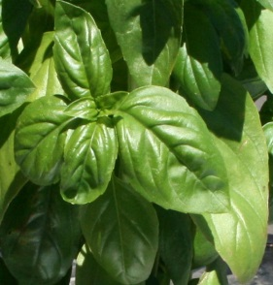

8 mL olive or vegetable oil
15 mL butter or margarine
½ med onion, finely chopped
450 g (1 lb) ripe Italian plum or Roma tomatoes, roughly chopped
1 clove garlic, roughly chopped
375 mL chicken or vegetable stock
(Stir 10-15 mL stock powder in to 375 mL hot water – adjust to taste)
60 mL dry white wine (or unsweetened white grape juice)
15 mL minced sundried tomatoes (or sun-dried tomato paste if available)
25 ml shredded fresh basil, plus a few small whole leaves for garnish
75 mL heavy (35% or whipping) cream
f.g. salt and pepper, to taste

- Heat oil and butter or margarine in a large saucepan (pot) at medium-low heat (#3-4) until it begins to foam. Add chopped onion and cook gently for about 3-5 minutes until softened and transparent but not browned.

- Stir in the chopped tomatoes and garlic, then add the stock, wine or juice, sun-dried tomatoes/paste and salt/pepper to taste. Bring to a boil over medium-high (#7-8) heat. Once the soup comes to a boil, lower the heat (#2-3), HALF-cover the pot, and simmer gently for 20 minutes. Stir occasionally to check that the soup is bubbling gently and to prevent the tomatoes from sticking to the bottom of the pot.

- Process the cooked soup with the shredded basil in a blender or food processor, then press through a sieve into a clean pot.

- Add the cream and heat through, stirring constantly. Do not allow the soup to approach the boiling point or the cream will curdle. Check the consistency and add more stock if the soup is too thick. Taste for seasoning and adjust if necessary (stock may be quite salty so be careful not to add too much salt).

- Pour into (heated) serving bowl and garnish with a small basil leaf. Serve immediately.

Variation: This soup can also be served chilled. Pour it in to a clean container after straining and chill for at least 4 hours. Serve in chilled bowls. Refreshing during hot weather!

CLAM AND PASTA SOUP
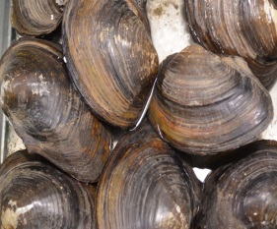
(Zuppa alle Vongole)
Makes 2-3 servings or One recipe per unit for sharing lab.
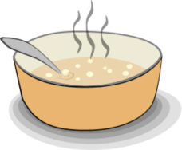
15 mL oil (preferably olive)
½ large onion, finely chopped
1 clove garlic, crushed
250 mL chopped or diced canned tomatoes
10 mL minced sun-dried tomatoes (or sun-dried tomato paste, if available)
2-3 mL granulated (white) sugar
2-3 mL dried mixed herbs (basil, oregano, thyme) or Italian seasoning
375 mL fish or vegetable stock
(Stir 10-15 mL stock powder in to 375 mL hot water – adjust to taste)
75 mL red wine (or unsweetened grape or apple juice)
60 mL small pasta shapes (shells, stars, alphabet, etc.)
125 mL canned clams in juice
15 mL finely chopped fresh parsley, plus a few whole leaves for garnish
f.g. salt and freshly ground black pepper

- Heat oil in a large saucepan (a pot) over medium-low heat (#3-4).Cook the onion gently for 3-5 minutes, stirring frequently, until softened and transparent but not browned.

- Add the garlic, tomatoes, sun-dried tomatoes (or sun-dried tomato paste), sugar, dried herbs, stock, wine or juice, and salt/pepper to taste. Stock can be quite salty so taste (with a clean spoon) before adding too much salt. Bring to a boil (heat #7-8). Lower the heat (to #2-3), HALF-cover the pan and simmer for 10 minutes, stirring occasionally.

- Add the pasta and continue simmering, uncovered, for 8-10 more minutes or until pasta is al dente (tender but firm, or “to the tooth”).

- Add the clams and their juice to the soup and heat through for 3-4 minutes, adding more stock if the soup becomes too thick. Do not allow to boil or the clams will be tough.

- Remove from heat, stir in the chopped parsley and taste the soup for seasoning. Be sure to use a clean spoon each time, or ladle a small amount of soup on to your tasting spoon.

- Serve hot, sprinkled with coarsely ground black pepper and reserved parsley leaves.

NOTE: If using juice instead of wine and if it makes the soup taste too sweet, try adding a splash of red wine vinegar or cider vinegar to balance the sweetness.

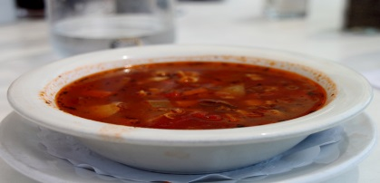
Cook’s Tip: This soup has a fuller flavour if it is made the day before and re-heated.

