Classic Macaroni Salad
3 Recipes per class

Ingredients:
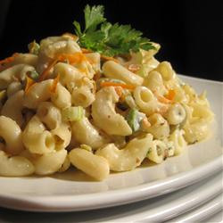
250 mL uncooked macaroni
95 mL mayonnaise
25 mL white vinegar
45 mL white sugar
10 mL prepared mustard
1 mL salt and pepper
1 green onion, chopped
1/2 celery stalk, chopped
1/4 bell pepper, chopped and seeded
1/2 carrot, grated

DAY 1 – Make Salad
1. | Bring a large pot of lightly salted water to a boil. Add the macaroni, and cook until tender, about 8 minutes. Rinse under cold water and drain.
2. | In a large bowl, mix together the mayonnaise, vinegar, sugar, mustard, salt and pepper. Stir in the onion, celery, green pepper, carrot and macaroni. Refrigerate for at until Day 2 of salad sharing lab.

DAY 2 – Eat Salad
- Serve salad with other salad from sharing salad lab!

