MEASURING INGREDIENTS Information Sheet

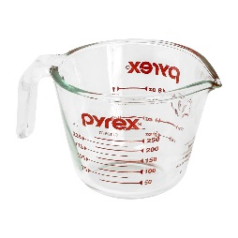
Tools:
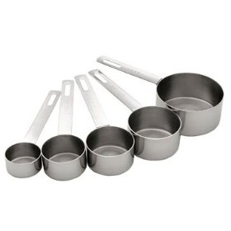
Liquid measure - Liquid measuring cups are used to measure liquids such as water, milk or oil. They have a spout for pouring. They have space above the top line to help prevent spills when moving the cup. One liquid cup can be used to measure many different amounts of liquid ingredients.

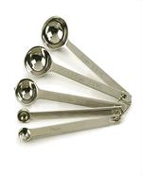
Dry measures - Dry measuring cups are used to measure dry ingredients such as flour, sugar, cornmeal or oats. Separate measuring cups are used to measure different amounts of ingredients. To be accurate, they must be completely full & levelled at the top.

Measuring spoons - Measuring spoons are used to measure small amounts of liquid OR dry ingredients. Separate measuring spoons are used to measure different amounts of ingredients.
How to Measure:
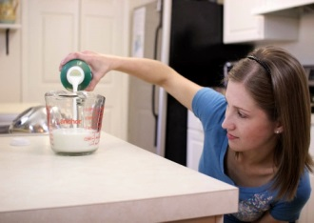
Liquid Ingredients - Fill a liquid measure to the desired level. Check for accuracy by placing the cup on a level surface. Lower your head so that your eyes are level with the mark you are checking. Match the mark with the bottom of the meniscus. Adjust the amount as necessary until level matches the mark.

Dry Ingredients - OVER FILL a dry measure cup. Use a metal spatula to level/scrape off the excess amount of ingredient. Be sure to do this over the container or a bowl, to catch the excess and avoid wasting ingredients or making a mess to clean up. A dry measure must be full and level in order to be accurate. If you use a liquid measure in error, you couldn’t level off the top of the dry ingredient.
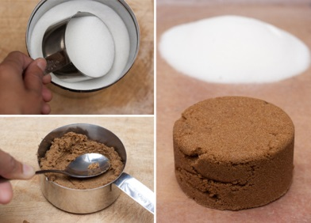
Brown Sugar - Over fill the correct size dry measure cup with brown sugar. Gently pack or press down the brown sugar with the back of a spoon. If necessary to fill the cup, add more brown sugar and repeat. Carefully level off with a metal spatula. If the brown sugar is sufficiently packed, it should hold its shape when the cup is turned upside down and lifted off the sugar.

Flour - Before measuring, sift the approximate amount of flour needed (a little extra is better) into a clean bowl. This adds air to the flour and ensures you don’t get too much flour. Next gently spoon the flour into the correct size of dry measure until it is overflowing. DO NOT shake, tap or pack down the flour! Level off the excess with a metal spatula. *NOTE - In some cases, it’s not absolutely necessary to sift the flour, but lifting with a fork to lighten it and add air may suffice. This is usually okay for cookies, muffins and loaves. For most cakes and cupcakes, sifting is preferable.

Solid Fats (butter, margarine, shortening …) softened/room temperature - Use a rubber spatula/scraper to fill a dry measure. Scoop in a bit at a time, and press down as you go to eliminate air bubbles. Level off with a straight edge. Using the rubber scraper will allow you to easily scrape all the fat out of the cup after measuring.
ABBREVIATIONS and MEASUREMENTS Fact Sheet
Keep this fact sheet on hand for understanding measurements in recipes …

Abbreviations:

sec. = second f.g. = few grains
min. = minute f.d. = few drops
hr. = hour tsp. = teaspoon
mL = millilitre tbsp. = tablespoon (may be Tbsp.)
L = litre c. = cup
g = gram pt. = pint (approx. 500 mL)
kg = kilogram qt. = quart
ºC = degrees Celsius lb. = pound
ºF = degrees Fahrenheit oz. = ounce (weight)
gal. = gallon fl. oz. = fluid ounce (volume)

Some Important Comparisons:

250 mL replaces an 8-ounce cup (approximation)
15 mL replaces 1 tablespoon
5 mL replaces 1 teaspoon

1 L is a little less than 1 quart
1 L equals 1000 mL

1 kg equals 1000 g
500 grams is a little more than a pound (1 lb = 454g)
30g is about 1 ounce

100ºC water boils (212 ºF)

1 cm slightly less than ½ inch
5 cm is about 2 inches

Metric Conversion:

1 quart = 1 L (1000 mL) 3 tbsp = 45 mL
1 cup = 250 mL 2 tbsp = 30 mL
¾ cup = 180 mL 1 tbsp = 15 mL
⅔ cup = 160 mL 1 tsp = 5 mL
½ cup = 125 mL ¾ tsp = 3 mL
⅓ cup = 80 mL ½ tsp = 2 mL
¼ cup = 60 mL ¼ tsp = 1 mL

Name: ______________________
Block: ______ Unit: ______

ABBREVIATIONS and MEASURING Questions
Using the ABBREVIATIONS and MEASUREMENTS Fact Sheet and the MEASURING INGREDIENTS Information Sheet, answer the following questions …

- What are the correct abbreviations for the following terms?

Litre ___________________________ few grains ___________________________
few drops _______________________ minute ______________________________
grams __________________________ hour ________________________________
kilograms _______________________ millilitre _____________________________

- The liquid measure has a pouring spout and a _________________ above the top line to help prevent spills when moving the cup.

- To accurately judge the level of the liquid, the measure must be placed on a ___________________

surface and checked at _______________ level.

- What do you have to do to brown sugar in a dry measure before you level it off?

_______________________________________________________________________________

- Use a ___________________ ___________________ to level off dry ingredients.

- Flour is always ____________________ or ____________________ BEFORE measuring.

One reason for this is to add more ____________________ to the baked product.

- Why can’t you accurately measure dry ingredients in a liquid measure?

(What do you need to do in a dry measure that you can’t do in a liquid measure?)

_______________________________________________________________________________

- Are measuring spoons used to measure liquid ingredients, or dry ingredients? _________________

- Label the following equipment:

_____________________________ ________________________
________________________

_____________________________

