**C:\Users\Vint\AppData\Local\Microsoft\Windows\Temporary Internet Files\Content.IE5\9G1WYC0I\MC900015854[1].wmf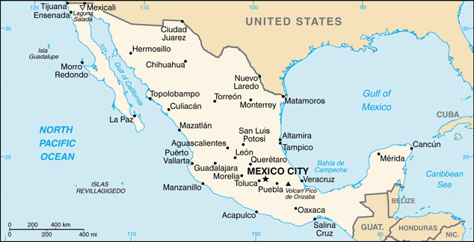FOOD IN MEXICO**

**An Introduction to Mexico**

The country of Mexico lies to the south of the United States and the two countries share a 2,000 mile border that stretches from California to Texas. To the west of Mexico is the Pacific Ocean and to the east, the Gulf of Mexico. Mexico’s neighbours to the south are Guatemala and Belize. This generally mountainous country has a large central plateau of between 3,000 and 6,500 feet high. The Sierra Madre mountain chains to the east and west meet south of the plateau near Mexico’s capital, Mexico City. There, the volcanic peaks of Popocatepetl and Citlaltepetl rise to heights of around 18,000 feet. Mexico’s current estimated population is around 123 million and increasing rapidly.

( <http://www.worldpopulationstatistics.com/population-of-mexico-2014/> ) Nearly one-third of Mexico’s people live in the three main cities: Mexico City, Monterrey and Guadalajara. Many people who were born in villages are moving to towns and cities in search of work and overcrowding is a problem in some places.

The population of Mexico is of mixed heritage. Until the early sixteenth century, the country was inhabited exclusively by Indians, including the Mayas and the Aztecs. The Indian cultures, rich in ceremony and steeped in tradition, have left a wealth of archaeological sites that are still being explored.

When the Spanish arrived in 1519, they found silver and other precious metals that they needed to finance their wars in Europe. They decided to stay and for almost three hundred years Mexicans and Spaniards intermarried. Soon most people were of mixed descent. Spanish became the national language and Christianity the national religion.

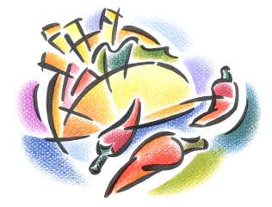C:\Users\Vint\AppData\Local\Microsoft\Windows\Temporary Internet Files\Content.IE5\H2GF2FA4\MC900233494[1].wmfMexico today is a developed industrial nation with an expanding economy based on minerals, oil and gas, and agriculture.

**Food in Mexico**

Mexico’s food, like its people, is a cheerful blend of Indian and Spanish. The Indian diet consisted of corn, beans, chilies, sweet potatoes, tomatoes, various squashes, avocadoes, nuts, vanilla, cocoa, bananas and other tropical fruits. Meat was limited to wild pig, deer, rabbit, armadillo and iguana. Those who were lucky enough to live near the coast had a choice of fish and seafood. The Indians invented hundreds of delicious ways to cook their basic ingredients and many of these recipes survive today.

…/2

- Page 2 -

The ***conquistadores*** (leaders of the Spanish conquest of America, Mexico and Peru in the 16th century) brought with them their favourite foods from Spain. Some of these, like oranges, rice and spices had been introduced to Spain when it was invaded by the Moors from North Africa in the eighth century. The great Spanish galleons also transported wheat, sugar cane, onions and garlic across the seas to Mexico. Noting that the land was suitable for livestock, they began to raise cattle, pigs, sheep and goats.

****Shopping is a social occasion in Mexico. In the cities, modern supermarkets (supermercados) have sprung up but most people still prefer to visit the local market to pick up fresh vegetables, herbs and spices. While out shopping, Mexicans frequently stop to chat with their friends and acquaintances. A typical Indian-style market is called a *tiangui*, a name that refers to the canvases used there. One canvas is spread out on the ground to display the vendor’s wares, while another is hoisted up overhead as protection against sun and rain.



**Agriculture in Mexico**

Mexico’s climate varies from extreme heat to extreme cold and much of its land is mountainous and dry. Only about half the land in Mexico can be farmed and only about one-eighth can be planted with crops. The non-agricultural areas contain the mountains, urban developments and forest.

The west coast and the northern plateau regions are exceptionally dry so nearly all the agricultural land there must be irrigated. Farther south, the rainfall increases and the land is easier to cultivate. In the tropical lowlands of the Yucatan Peninsula, however, the rain brings drainage problems that often result in flooding. This means that to expand the country’s farm land, Mexico must bring more land under irrigation or drain and develop the lowlands. Both options are expensive.

Most Mexican farms are comparatively small. One of the results of the Revolution of 1910 was that the large, privately-owned estates were split up into smaller units. Today, privately owned farms or ranches must not have more than 600 acres of grazing land or 300 acres of irrigated land. Some farms, called *ejidos*, owned by the government and operated by a group of villagers or a family unit, are smaller. With an average size of 35-40 acres, *ejidos* are too small to mechanize and run efficiently so the yield per acre remains low.

Even though Mexico has not yet fully developed its agricultural potential, it is the world’s sixth largest meat producer and the seventh most important fishing nation. Over twenty of its crops are placed in the top ten of world production, including corn, cotton, tomatoes, avocados, peppers, sugar cane, citrus fruits and tea. Most of Mexico’s agricultural produce is consumed locally.

…/3

C:\Users\Vint\AppData\Local\Microsoft\Windows\Temporary Internet Files\Content.IE5\EG73OV9M\MC900019458[1].wmf- Page 3 -

**Regional Cooking**

Certain foods such as tortillas, tomatoes, onions, garlic and chilies are used for cooking throughout Mexico but many towns also have their own special recipes. Some have even become famous. These dishes are usually based on local ingredients that are considered the best of their kind. Others may be attributed to a certain type of cooking that has been invented or perfected in the town.

The town of Puebla, 80 miles southeast of Mexico City and nestled high in the rugged mountains, is often referred to as Mexico’s gastronomic centre. Puebla’s cuisine was influenced by the French when, during another turbulent episode in Mexico’s history, they held the town as part of their territory under the control of the Emperor Maximilian. Puebla has become famous for its ***mole Poblana***, a savoury chocolate sauce derived from an old Indian recipe – it is served with chicken or turkey.

Most of Mexico’s beef is produced in the northern states of Sonara, Chihuahua, Coahuila and Nuevo Leon. High in the eastern Sierra Madre Mountains, Monterrey is renowned for its excellent beef and goat meat. Traditionally, food in this area is heavy and very filling. The ranch workers need three hearty meals each day, probably beginning with *huevos rancheros*, or ranch-style eggs, that are served with beans, avocado and tortillas.

C:\Users\Vint\AppData\Local\Microsoft\Windows\Temporary Internet Files\Content.IE5\9G1WYC0I\MC900410799[1].wmfC:\Users\Vint\AppData\Local\Microsoft\Windows\Temporary Internet Files\Content.IE5\N3PT1A0Y\MC900098065[1].wmfFish and seafood have always played an important part in the Mexican diet. Montezuma, the Aztec Emperor, used to have fresh fish brought to his court in what is now Mexico City by runners from the seaport of Veracruz. Both the Pacific and Gulf waters are rich in seafood. The Gulf of California has wonderful oysters and abalone, while the gentle east coast waters provide many kinds of fish, crabs, lobster and shrimp.

C:\Users\Vint\AppData\Local\Microsoft\Windows\Temporary Internet Files\Content.IE5\N3PT1A0Y\MC900001251[1].wmf

**Food in Mexico** **NAME ____________________**

**BLOCK _______ UNIT _______**

1. Mexico’s neighbours to the north are ______________________________________________ and _________________________________ and to the south, ____________________________ and ______________________________________ .
2. What have the Indians of Mexico added to the country? __________________________________

________________________________________________________________________________

________________________________________________________________________________

1. When the Spanish arrived in 1519, what made them stay and what is the result of their inhabiting Mexico? _________________________________________________________________________

________________________________________________________________________________

________________________________________________________________________________

1. How was the city of Puebla influenced by the French? What is the result of this influence? ________________________________________________________________________________

________________________________________________________________________________

________________________________________________________________________________

1. Who is Montezuma and what is his significance? ________________________________________

________________________________________________________________________________

________________________________________________________________________________

1. Describe the influence of the Spanish and the Indians on Mexican cuisine. ___________________

________________________________________________________________________________

________________________________________________________________________________

1. Why are the farms of Mexico relatively small and what foods are produced? Be specific to the regions. _________________________________________________________________________

________________________________________________________________________________

________________________________________________________________________________