**OATMEAL FRUIT COOKIES**

Yield: 12-18 cookies

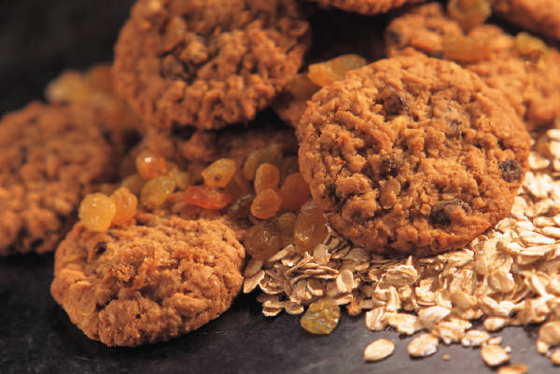250 mL rolled oats

185 mL all-purpose flour

125 mL brown sugar

60 mL white sugar

2 mL salt

2 mL baking soda

125 mL margarine

1 egg

185 mL dried fruit*, chopped

**\*Note:** Measure carefully so as not to pack down dry ingredients or cookies will be dry.

1. Place oven racks in the centre and one below centre positions. Preheat oven to 375ºF (190C).
2. Grease baking pans with shortening.
3. In a medium-large bowl, beat margarine with an electric mixture until softened. Add brown and white sugars and continue beating until the mixture is light and fluffy. Add egg and beat until blended.
4. Meanwhile, in a smaller bowl, combine oats, flour, salt and baking soda. Stir well to combine. Stir in dried fruit.
5. Using a wooden spoon, stir/beat dry ingredients in to creamed (margarine/sugar/egg) mixture until thoroughly mixed.
6. Drop spoonsful of the mixture about 15 mL at a time (at least 25 mm/1 inch apart) onto the prepared pan.
7. Bake for about 12 minutes or until the edges are golden brown. Be careful to check that the bottoms of the cookies do not burn. Rotate pans to the higher/lower position halfway through the baking time.
8. When baked, remove cookies from pans and place on wire racks to cool. For faster clean-up, place paper towels on wire racks first – this will also help absorb excess grease from cookies.

C:\Users\Vint\AppData\Local\Microsoft\Windows\Temporary Internet Files\Content.IE5\H2GF2FA4\MC900239563[1].wmfC:\Users\Vint\AppData\Local\Microsoft\Windows\Temporary Internet Files\Content.IE5\N3PT1A0Y\MC900384360[1].wmf**\* Note:** Any **dehydrated** fruit may be used – apples, figs, cherries, blueberries, dates, cranberries, bananas, apricots, pears, peaches, raisins, coconut, etc.