Omelette
Serves 2-3
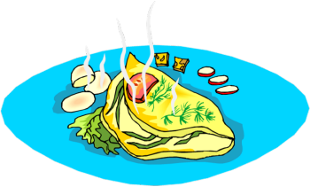
Ingredients:
2-3 eggs (1/person)
30-45 mL milk (based on # of eggs)
f.g. salt and pepper
5 mL oil

Filling:
25 mL grated cheese
½ piece of bacon
f.g. oregano and/or basil
½ green onion, chopped
⅛ bell pepper, chopped

Directions:
- Cook bacon (see method below).
- Prepare omelette filling ingredients (wash, chop).
- In a small bowl, beat together eggs, milk, salt and pepper with a fork.
- Preheat a frying pan on medium heat (max. #3) for 1-2 minutes only.
- To test if the frying pan is hot enough, put a drop of water on the pan. When the water sizzles, it is hot enough (don’t over-heat).
- When frying pan is hot, add the oil and pour in the egg mixture.
- As eggs begin to set at the edges, use a spatula to gently push cooked portions to the center, tilting the frying pan to allow the uncooked egg to flow into the empty spaces. Shake gently to keep eggs from sticking to the bottom.
- When egg is almost set on the surface, but still looks slightly moist, place the filling and spices in a line along the top third of the omelette. Loosen outer edges of the omelette all the way around.
- Slip spatula/flipper under top third and fold just over filling. Slide unfilled edge onto serving plate and gently invert the pan to fold the top (folded) section over the bottom edge. It will continue to cook from its own heat, so remove from frying pan before completely cooked.

Method for Cooking Bacon:
- Turn small stove element to medium-low heat (#3-4).
- Preheat a frying pan for 1-2 minutes (maximum). Cut bacon strips in half and place in pan.
- Cook bacon until one side is cooked (meat is no longer red, fat is translucent)
- Flip bacon using tongs and cook the uncooked side as above.
- **NOTE: DO NOT POUR BACON FAT DOWN THE SINK! Using tongs and a paper towel, remove any excess fat by soaking it up with the paper. Place the greasy paper towel in the garbage or compost bin. Don’t wash the pan yet - use the small amount of bacon grease residue to grease and flavour the pan for cooking your omelette.
- When bacon cools, cut into small pieces.

