Pasta with Alfredo Sauce

Serves 2-3 | Ingredients | Serves 4-5
25 mL | margarine | 40 mL
1 | clove(s) garlic, minced | 1 – 1½
25 mL | flour | 40 mL
250 mL | milk | 375
50 mL | Parmesan cheese | 80 mL
To taste | ground black pepper | To taste
To garnish | parsley, chopped | To garnish

To prepare pasta: Approximately 125 mL pasta shapes per person (penne, rotini, fusilli, etc.)

- Fill a large pot (for 2-3 people) or Dutch oven (for 4-5 people) ⅔ to ¾ full with cold water. Add 1-2 mL salt. Bring to a full, rolling boil on high heat.
- Add pasta to boiling water and stir occasionally until the water returns to a full boil.
- Cook pasta for 7-10 minutes (depending on size/shape) until al denté, or until tender to the tooth/fork, but not mushy.
- Drain in a colander and serve hot.

To prepare sauce (while pasta is cooking):

- In a small saucepan (pot), melt the margarine over medium-low heat (#3-4). Add the minced garlic and cook for 1-2 minutes, or until the garlic is a light, golden brown.
- Add the flour to the margarine/garlic and cook, stirring, for about 30 seconds. This fat/flour mixture is called a “roux.” The function of the roux is to thicken the sauce.
- Using a whisk, add the milk gradually to the roux, whisking constantly and scraping the bottom of the pot. Cook sauce until just thickened (approximately 3-4 minutes). This is called a “white sauce.” **NOTE – Do not over-thicken the sauce. It should still flow from a spoon and should NOT begin to look like gelatin.
- Add the cheese and pepper to the sauce. Stir until combined, then immediately remove from heat.
- Pour the Alfredo sauce over the drained pasta and toss to coat pasta. Garnish with chopped parsley and serve hot.

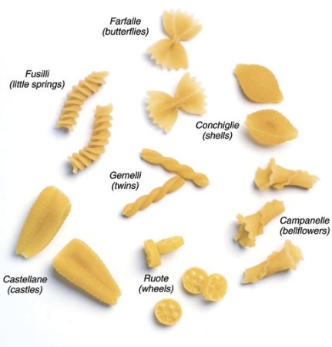
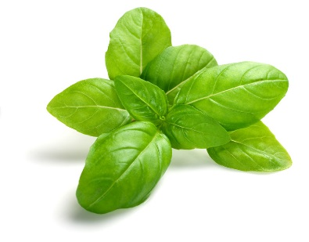
*Try at home … To make Pesto Alfredo Sauce, stir in 15 mL of prepared pesto sauce to Alfredo sauce
just before mixing the sauce with the pasta.

Foods 11-12(A) 2016 Vint

