Pasta with Fresh Tomatoes and Cheddar
(for 2-3)
Preparation Time: 15 minutes Cooking time: 8 minutes

150 mL dried pasta (in bite-sized shapes: rotini, penne, fusilli, radiatore, etc.)
5 mL olive oil or vegetable oil
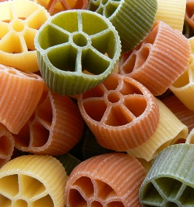
½ clove garlic, minced
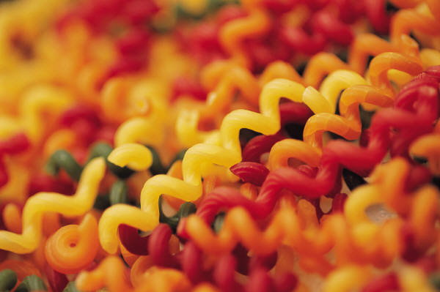
½ mL red pepper flakes
¼ med. zucchini, coarsely chopped
1-2 mL dried basil leaves
1-2 mL dried oregano leaves
1 med. tomato, chopped
Pinch each salt & pepper (to taste)
75 mL medium cheddar cheese, cut into small cubes
½ green onion, sliced

- Fill a large saucepan (pot) about 2/3 full of water and bring to a full rolling boil over high heat.
- Add dried pasta and allow water to return to a full boil.
- Cook pasta at a full boil for 7-10 minutes or until al dente (just tender). Drain in a colander.
- While pasta is cooking, prepare and cook vegetables.
- Preheat oil in a large, shallow skillet (frying pan) over medium heat for a minute or so (not TOO hot).
- Add minced garlic and red pepper flakes and sauté for about 30 seconds.
- Add zucchini and herbs. Sauté for a further 2-3 minutes, just until zucchini begins to soften.
- Stir in tomatoes and just heat through, about 1-2 minutes.
- Remove from heat. Add drained pasta, cheese cubes and green onions to the skillet and toss to coat.
- Serve immediately.

Variations: To boost nutritional value and visual interest, try using one of the many coloured varieties of pasta available (tomato, spinach, or even black squid ink) or whole wheat pasta.

If you have fresh herbs available (basil &/or oregano) use at least double the amount of dried in the recipe. Dried herbs have a more concentrated flavour and you always use less than if you use fresh herbs.

This is not a “tomato sauce” type of pasta, but tomato sauce to taste could be added with the fresh tomatoes and heated through. Alternatively, a small amount of olive oil could be drizzled over the top upon plating.
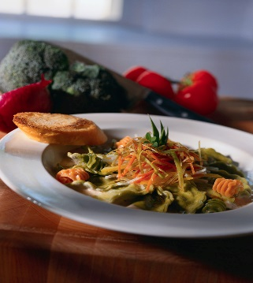

Vint 2014

