SESAME SOBA WITH KALE
SERVES 2-3
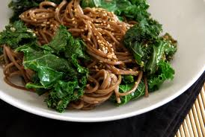
INGREDIENTS:
¼ bunch kale (about 3 large leaves)
1 bunch soba noodles (about 100g)
15 mL sesame oil
15 mL soya sauce
½ carrot, peeled and grated
15 mL toasted sesame seeds

INSTRUCTIONS:
- Bring a medium pot of water to a boil over high heat.
- Prepare kale: hold the bunch of kale together and slice off and discard thickest part of stem. Still holding the kale in a bunch, slice remaining stems and leaves crosswise as thin as you can. Set kale in a large bowl of cold water and swish vigorously to remove any grit. Repeat this process with fresh water if the kale seems especially dirty. Lift out kale, place in colander and rinse thoroughly.
- When water in the pot has come to a full rolling boil, add soba noodles and kale and cook for 5 minutes. Press kale down with the back of a large spoon to submerge it if it floats to the top.
- Drain soba and kale in a colander. Rinse with cold water, drain again and return to pot.
- Add sesame oil and soya sauce and toss with a fork. Add toasted sesame seeds and toss again.
- Add peeled and grated carrot to noodle mixture and toss to combine.
- Serve at room temperature.

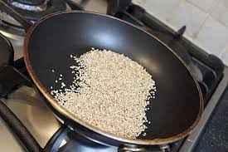
How to Toast Sesame Seeds
If you cannot find toasted sesame seeds at the grocery store, you can buy raw sesame seeds and toasted them yourself at home. Place sesame seeds in a frying pan over medium heat. While stirring constantly, toast seeds until they are golden in colour. Be careful not to burn them.

