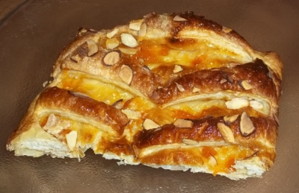
Apricot and Almond Jalousie (Strudel)
One recipe per unit of 4-5 people

Jalousie means “shutter” in French, and the traditional slatted puff pastry topping of this fruit “pie” looks exactly like the shutters which adorn the windows of French houses.

Very similar to a combination of a turnover and a strudel, this food item is a delicious French pastry containing a sweet filling. Made from puff pastry dough that is baked into a light and fluffy crust, a Jalousie typically has baked fruits that provide a thick and syrupy filling within the thin outer crust.

225 g ready-made puff pastry
10-15 mL egg wash (beaten egg diluted with a little water - about 4:1 ratio of egg to water)
60 mL apricot conserve - other flavours of conserve or jam will work as well
25 mL sliced/flaked almonds
15-25 mL sugar

- Preheat oven to 425˚F with rack positioned slightly below centre.
- Roll out pastry on a lightly floured surface to make a 30-cm/12” square.
- Cut in half to make two rectangles.
- Place one piece of pastry on a piece of parchment paper and brush around the edges with egg wash.
- Spread conserve/jam over the pastry, leaving a 1-2 cm border around the edge with no filling.
- Fold the remaining rectangle in half lengthwise and cut about 8 diagonal slits from the centre fold to within about 1 cm/½” from the edge all the way along the length of the pastry.
- Unfold the pastry and lay it on top of the conserve/jam covered pastry on the parchment paper. Press the pastry edges together well to seal.
- Brush the slashed pastry with egg wash and sprinkle with almonds and sugar to taste.
- Brush excess loose sugar off the parchment paper and transfer pastry and paper to a baking sheet.
- Bake for 25-30 minutes, until well risen and golden brown.
- Remove the jalousie from the oven and transfer (on the paper still) to a cooling rack and allow it to cool.
- Serve at room temperature with whipped cream or natural yogurt.

Cook’s Tip: Use other flavours of fruit conserve to fill the jalousie or substitute some canned fruit pie filling instead. You could also make smaller, individual jalousies to serve with morning coffee or afternoon tea.
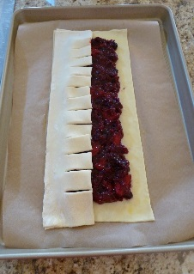
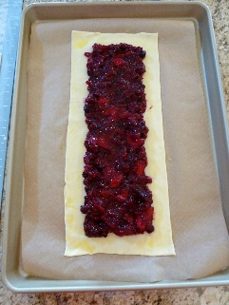
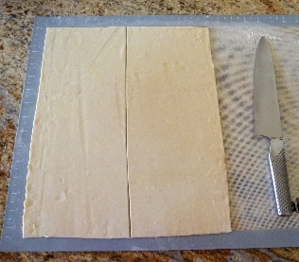
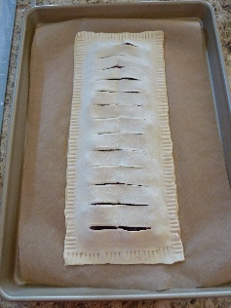
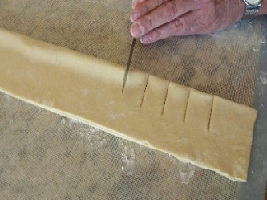

Foods 11-12(A) 2017

