Foods 11-12(A) 2017
SPANAKOPITAKIA
Mini Spinach Pie Triangles
One recipe per unit (makes 8 pieces)

These bite-sized triangles are often referred to as “Spanakopita” or “Spanekopita.”
This is actually incorrect for these appetizer bites and should refer, instead, to a full-sized spinach pie.

Filling Ingredients:
75 g frozen chopped spinach, thawed and drained (¼ of a 300g block)
50 mL crumbled feta cheese (approx. 50g)
25 mL cream cheese (approx. 25g)
50 mL dry curd cottage cheese
1 egg, separated
2 small green onions (or 1 large), finely chopped
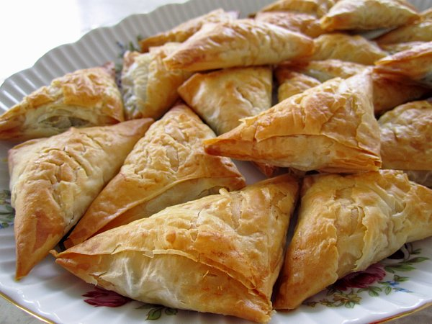
3 mL dried dillweed

Wrapping ingredients:
4 sheets phyllo pastry (about ¼ of a 454g package)
50 mL melted margarine

Preheat oven to 350ºF (180C)

To make filling:

- Squeeze out any excess moisture from spinach by placing spinach on a paper towel, then squeezing it over a bowl or an empty sink. If using whole-leaf spinach, chop fairly small. Place spinach in a small mixing bowl. Add remaining filling ingredients except for egg white (crumbled feta, softened cream cheese, cottage cheese, egg yolk, green onion and dillweed).

- Beat egg white in a small bowl until stiff peaks form. Fold into spinach-cheese mixture.

- Assemble phyllo triangles as directed in diagram (see over).

How to assemble Triangle Pites (Trigona):

- Phyllo pastry is can be found in the freezer section of the grocery store. It must be thawed overnight (24 hours) in the refrigerator before use. Remove phyllo from the package. Unroll and lay it flat on a clean, DRY counter surface.

- Cover dough loosely with plastic wrap first, and then cover that with a slightly damp tea towel.

... (turn page over)
~ Page 2 ~

- Using a cutting board under the stack of dough, carefully cut the sheets of dough in half, “hamburger-style.”

- Work with ONE half-sheet at a time, being careful to keep the rest covered to avoid drying out.

- The next step may be accomplished with either of two methods:
a) cut the half-sheet in half again to create 2 strips (as shown below with the whole sheet) and brush both lightly with melted margarine before carefully stacking one strip directly on top of the other, or
b) brush half of the half-sheet lightly with melted margarine and fold the other half over the margarine. Then, brush the top layer with margarine.

- Place about 10 mL (2 tsp) of filling on the bottom end of one double-layer strip of phyllo (see diagram). Lift the corner of the phyllo and fold it over so it forms a right-triangle. Continue folding tightly along the folded edges until a triangle-shaped pita is created. Brush each triangle with margarine, top and bottom, then place on a baking sheet pan. Using the sharp tip of a paring knife, carefully make a tiny slit in each side (near the top surface) to allow steam to escape during baking.

- Sprinkle with a few drops of water to prevent curling of top layers and to encourage even browning.

- Bake in preheated oven (350ºF/180C) for about 20 minutes or until medium-golden brown. Allow to cool slightly before serving to allow cheese to set and to avoid mouth burns.
