Name ____________________________ Block _______
Pattern Layout Demonstration

- P __ __ __ __ __ __ L __ __ __ __ __ means placing and pinning the tissue paper pattern on fabric.
- The (grainline arrow) on the tissue pattern means you should lay the pattern on the
L __ __ __ __ __ __ __ __ __ grain of the fabric. This means the grainline arrow runs
p __ __ __ __ __ __ __ with the selvage edges. You must measure it accurately with your
t __ __ __ m __ __ __ __ __ __ .
- Pin grainline arrows FIRST on all pattern pieces before you pin any other parts of the pattern.
Make sure that they are an equal distance at both ends to the s __ __ __ __ __ __ edges.
- Next, pin all c __ __ __ __ __ __ . Pin diagonally toward the centre of each piece.
- Then, pin out through the n __ __ __ __ __ __ , so that you do not cut these markers off and they can be used to match fabric pieces later when sewing.
- Finally, pin so that there is a pin about every 10 cm, or the distance between your index finger and
t __ __ __ __ when spread apart.
- All pins must be places INSIDE the c __ __ __ __ __ __ line. Shears will NOT cut through pins!!!
- Except for corners, pins are usually p __ __ __ __ __ __ __ __ __ __ __ __ to the cutting line. ( --| )
- Remember to get teacher’s approval BEFORE you cut out pieces!
- Do not remove pattern pieces until markings are done. That is, if you need to use tailor’s chalk or marking pencils to mark “F” on the pattern fronts and “B” on the pattern backs. Make sure you mark on the w __ __ __ __ sides of the fabric.
- Identify 5 things that are wrong in the pattern layout below.
  - ________________________________________________________________________
  - ________________________________________________________________________
  - ________________________________________________________________________
  - ________________________________________________________________________
  - ________________________________________________________________________
Selvage edges (matched)
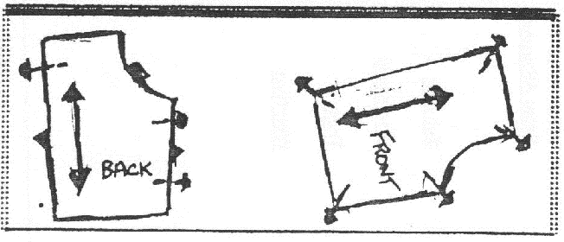
Raw edge (folded with right sides together)

