THE STRAIGHT GOODS
GRAIN: is the direction in which threads run in a piece of woven fabric
SELVAGE: the “finished” or un-cut edges of the fabric
LENGTHWISE GRAIN: indicates the threads which run parallel to the selvage edges
CROSSWISE GRAIN: indicates the crosswise threads which run from selvage to selvage, or perpendicular (90º angle) to the selvages
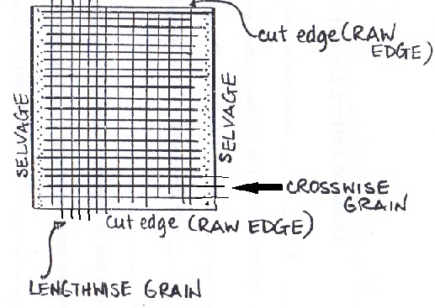

VOCABULARY

Casing: where the elastic for the waist will go

Centre Seam: the seam that runs down the centre front, under and between your legs, and then up the centre back

Grainline: place this arrow parallel with the lengthwise grain and the selvage edge

Hem: the bottom of pants where you fold up so you don’t have a raw edge

Inseam: the seam that runs down the inside of your leg

Notch: notches are used for matching pieces together. There are single, double and sometimes triple notches. You cut them out away from the pattern piece. They tell you how to put pattern pieces together to sew your garment.

Press: use an iron to make or remove folds

Seam Allowance: distance between the stitching line and the raw/cut edge of the fabric. You will be using a seam allowance of 1.5cm for your project unless otherwise specified.

Selvage: finished lengthwise edge of the fabric

Side seam: the seam that runs down the outside of your leg

Trim: to cut thread or fabric

Waistline: where the pattern/garment will fit you at your waist

