POTATO PANCAKES
Serves 2-3

¼ small-medium onion, minced
1 ½ medium potatoes (washed, peeled & grated – medium/large shred)
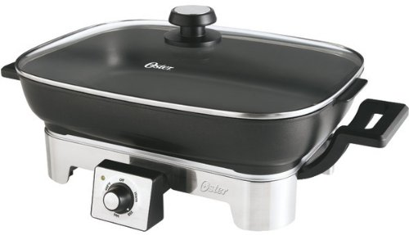
½ egg, slightly beaten
15 mL flour
1 mL salt (or to taste)
½ mL ground black pepper
2 mL baking powder

25-50 mL sour cream, for serving, on the side

- Combine all prepared ingredients above EXCEPT the sour cream.

- Heat a large electric frying pan to about 300-325ºF with about 10-15 mL oil.

- Using a 60 mL size dry measure for portioning, place piles of mixture in pan. Gently spread the mixture to form a “patty” but don’t flatten or press down.

- Allow each pancake to fry to a medium-dark golden brown before flipping to cook the other side. Try to flip only once so they do not break apart & be careful not to burn them.

- Serve hot with sour cream on the side. Makes about 6 pancakes.

Vint 2015 Foods 9-10 A

