Foods 9-10(A) 2017 Vint
SOFT PRETZELS
Makes 6 pretzels. One recipe per unit.

Day 1 – Make dough

12 mL rapid acting yeast 200 mL all-purpose flour
175 mL hot tap water 200 mL whole wheat flour
12 mL sugar 25 mL margarine
5 mL salt

- Stir together all-purpose and whole wheat flours in a medium mixing bowl.

- Place 100 mL of flour from the medium bowl into a small mixing bowl. Stir in the yeast, sugar and salt.

- In a large mixing bowl, cream the margarine with a wooden spoon until really soft and lighter in colour. Add the flour/yeast mixture from the small bowl and stir lightly to combine.

- Warm a small liquid measure under hot, running water, then measure 175 mL of hot tap water. Add this hot water to the flour/yeast mixture in the large bowl and beat the mixture vigorously with a wooden spoon until it looks like a smooth, thick paste.

- Gradually add the flour from the medium bowl to the large bowl until the dough forms an irregular ball that comes away from the sides of the bowl. You MAY not need to use all of the flour that you measured. The dough will be slightly sticky when you are ready to begin kneading.

- Turn the dough onto a lightly floured surface and knead until smooth and elastic. Continue to add flour, small amounts at a time, until the dough is soft and pliable and no longer sticks to your hands or the work surface. This will take 5 to 7 minutes of firm kneading. (Fold, press, turn, fold, press, turn …)

- Place dough in a LIGHTLY-oiled, labeled bag. Yeast dough WILL expand, so be sure to leave a TINY opening in the seal for gas to escape.

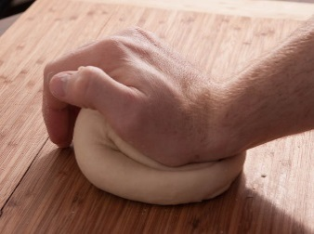
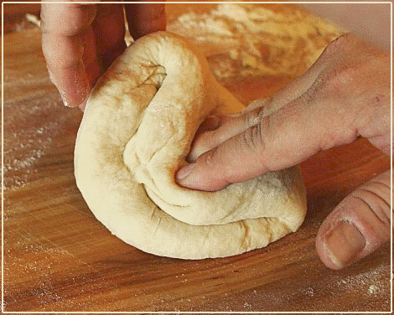
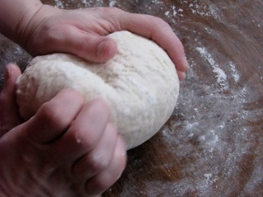
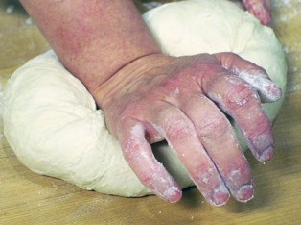

Foods 9-10(A) 2017 Vint
SOFT PRETZELS
Makes 6 pretzels. One recipe per unit.

Day 2 – Shape pretzels, add toppings and bake

Topping ingredients (choose ONE):

Pizza Topping: Cinnamon/Sugar Topping: Cheese Topping:

25 mL tomato paste 15 mL margarine, melted 15 mL margarine, melted
2 mL dried basil 15 mL white sugar 25 mL Parmesan cheese
2 mL dried oregano 5 mL ground cinnamon pinch coarse salt (optional)
2 mL garlic powder
50 mL grated cheese

Method:

- Check that oven rack is in centre position and preheat oven to 425ºF (220C).
- Lightly grease a baking sheet pan with shortening.
- “Punch down” dough and knead gently a few times to break any large air bubbles.
- Cut dough in half and divide each piece into 3 equal sections. On a slightly greased surface, roll out each piece into a rope about 30 cm / 12” long.
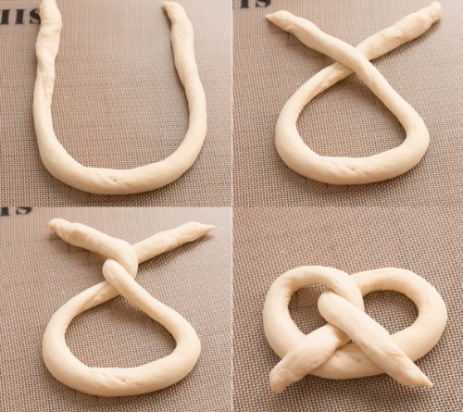
- To form the pretzel shape. Twist the ends together and then fold the ends over into the middle loop (see picture ).
- Place the pretzels on the greased pan, making sure there is enough space between each one so they do not touch as they expand. If there is enough time, cover the pretzels with a clean tea towel and let rest until doubled in size.
- Mix together topping ingredients, if required. Brush melted margarine or seasoned tomato paste on tops of risen pretzels and sprinkle with any additional topping ingredients.
- Bake in preheated oven for 7 to 10 minutes or until golden brown.
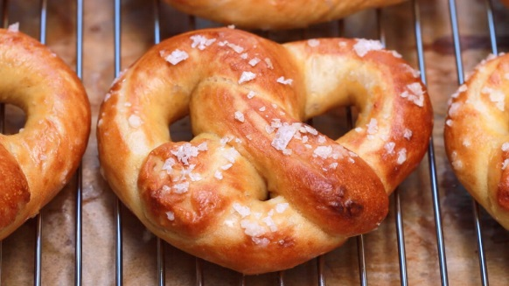
Serve warm.

