Foods 11-12 Food Preservation – Canning
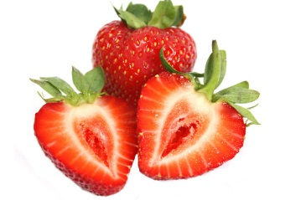
Tropical Twist Strawberry Jam
Makes 2 x 250 mL jars

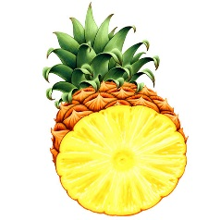
250 mL crushed strawberries (measure carefully AFTER crushing the berries)
450 mL granulated (white) sugar
80 mL crushed pineapple (include a small amount of juice)
20 mL powdered fruit pectin (or ⅓ of a 57g package)

TIPS:
** Never alter amounts of ingredients in a canning recipe – they all serve important functions!
*(Step 1) Sterilize ALL utensils by placing them in the boiling water bath along with the preserving jars
*(Step 6) Cooking times may vary, depending on the type of fruit and the amount of pectin present (naturally and/or added). Most jams are ready when the jam holds its shape somewhat on a spoon. It will thicken as it cools. Using a timer (MINIMUM times) is essential for product success and food safety.

- Prepare a boiling water bath canner by filling with water almost to the top and bringing it to a full, rolling boil. Place 2 clean canning jars (washed in hot, soapy water), along with any utensils that will touch the jam, in the boiling water. Make sure the jars remain upright, so that there are no air bubbles inside them. Cover and bring water back to a boil. AFTER the water returns to a hard boil, set a timer for 10 minutes (MINIMUM) and boil the jars to sterilize. It is fine if the jars boil longer than 10 minutes.
** Leave the jars in the boiling water until you are ready to fill them. Remove only ONE jar at a time to fill them. Replace each filled jar into the water BEFORE removing the next jar from the water to fill it.

- In a small pot, simmer SNAP lids for 5 minutes (not longer – use a timer!) to soften the sealing compound. After 5 minutes, turn the heat off and leave the lids in the hot water until ready to use.

- Fill a separate, medium pot with water and keep hot (simmering) to “top up” the canning water.

- Wash, hull and crush strawberries using a potato masher. If using frozen berries, defrost, than crush them. Measure 250 mL of fruit. (With this recipe, you could also use a combination of strawberries and blueberries, if desired.)

- Combine prepared fruit with crushed pineapple in a large, deep pot. (The “Dutch oven” pots in the drawer under our ovens are a good size.)

- Whisk in powdered fruit pectin until completely dissolved.

- Stirring frequently, bring the mixture to a boil over high heat on a large element. Stir in sugar.

- Stirring constantly, return the mixture to a full, rolling boil that can’t be stirred down and boil hard for one minute. Use a timer!!

- Remove jam from heat. Skim off any foam that has collected on the surface of the jam. Use a large metal spoon, as the foam will cling to the metal surface.

- Using a funnel and a ladle (or a sterilized 250 mL liquid measure), carefully, but quickly, scoop jam into one sterilized jar, allowing 1 cm head space (above jam). Try to avoid spilling jam on the rim of the jar.

- Run a sterilized small rubber spatula or other non-metallic utensil around the inside of the jar to remove any air bubbles.

- Wipe the rim of the jar with a clean, damp cloth to remove any stickiness that could prevent the jar from sealing. Centre the SNAP lid over the jar. Apply the screw band securely, but ONLY finger-tip tight. DO NOT OVER-TIGHTEN! Over-tightening will prevent air from escaping and therefore, prevent a vacuum seal from forming.

- Using a jar lifter tool, lower the jar into the boiling water, being very careful not to tip the jar.

- Repeat the above process with another jar. Make sure the jars are covered with a MINIMUM of 2½ cm (1”) of water ABOVE the tops of the jars. Add water, if necessary, from extra pot of water.

- Cover the pot and return the water to a full rolling boil. AFTER the water returns to the boil, USE A TIMER and process (boil) the filled jars for 5 full minutes.

- Using the jar lifter tool, remove the jars from the boiling water without tilting them and place them on a wire rack. DO NOT TIGHTEN THE SCREW BANDS!!!!! You should, within a minute or 2, hear a “snap” sound, which will indicate the jar has sealed. The lid should also appear to curve downward, indicating a vacuum seal has formed. Allow the jars to cool, upright and undisturbed, for 24 hours.

- Store sealed jars, upright, in a cool, dark place to avoid discolouration.

