STREUSEL COFFEE CAKE
One recipe per unit of 4-5 people

Coffee cake does not necessarily contain coffee as an ingredient;
rather, it is meant to be served as a sweet snack with coffee.

CAKE BATTER: TOPPING:
80 mL margarine 125 mL sugar
125 mL sugar 15 mL flour
1 egg 5 mL cinnamon
375 mL flour 125 mL chopped walnuts
10 mL baking powder 45 mL margarine
2 mL salt *NOTE – if you prefer a less sweet topping,
185 mL milk try using only 60-80 mL sugar

- Preheat oven to 375ºF. Grease and flour an 8” x 8” square cake pan.
- Cream margarine and sugar for cake batter. Add egg and beat until light and fluffy.
- Sift together flour, baking powder and salt.
- Stir in dry ingredients and milk alternately to the creamed mixture, starting and ending with the dry ingredients. (⅓ of dry, ½ of milk, ⅓ of dry, remaining milk, remaining dry)
- Spread batter evenly in to prepared cake pan.
- Mix together topping ingredients in a separate bowl.
- Sprinkle topping over the top of the cake – do not spread or smooth topping.
- Bake for 30 minutes or until a cake tester inserted in the centre comes out clean.

Questions for Streusel Coffee Cake lab:

- When you see the word “cream” in a recipe, you should use a(n) ____ELECTRIC MIXER____ to make the job faster and easier.

- What happens if you do NOT start and end with flour when you are adding in the wet and dry ingredients alternately? THE CAKE MAY NOT COOK PROPERLY AND MAY BE SOGGY IN THE MIDDLE

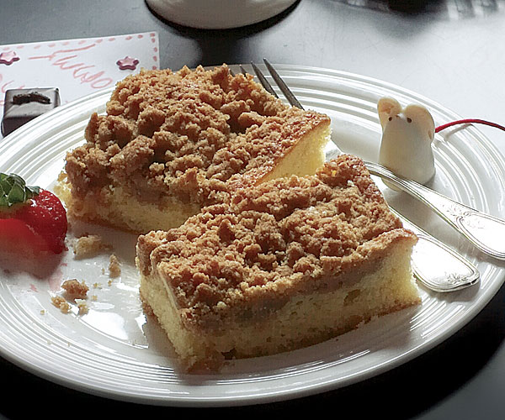

Revised 2015 Vint Foods 9-10 A

