**SUGAR COOKIES**



125 mL butter or margarine, softened

125 mL sugar

½ egg

2 mL vanilla

250 mL flour

1 mL baking powder

**DAY 1:**

1. In a large bowl, beat/cream butter/margarine.
2. Gradually beat in sugar until mixture looks light and fluffy.
3. Beat in egg and vanilla.
4. In a separate bowl, mix flour with baking powder.
5. Stir dry ingredients into butter mixture, combining well.
6. Divide dough into 2 equal portions, flattening portions into discs. Wrap discs in plastic wrap, being sure they are completely air-tight. Place on tray to refrigerate until next class.

**DAY 2:**

1. Preheat oven to 375ºF.
2. Roll out dough on a lightly floured surface until about 5 mm (¼ inch) thick.
3. Cut into desired shapes and transfer cookies to ungreased baking sheets, placing cookies about 2½ cm (1 inch) apart.
4. Gather scraps of dough and gently press together without kneading. Re-roll dough and cut out more cookies.
5. Bake cookies for 10-12 minutes or until bottoms and edges are a **light** golden brown.
6. Allow cookies to cool slightly on baking sheet for a few minutes and then transfer cookies to paper towel-covered wire cooling racks to cool completely.

C:\Users\Vint\AppData\Local\Microsoft\Windows\Temporary Internet Files\Content.IE5\5YSIQ74W\MC900155490[1].wmf

Vint 2011



C:\Users\Vint\AppData\Local\Microsoft\Windows\Temporary Internet Files\Content.IE5\UIMNTJPI\MC900279310[1].wmfC:\Users\Vint\AppData\Local\Microsoft\Windows\Temporary Internet Files\Content.IE5\6RYWVBUY\MC900298797[1].wmf C:\Users\Vint\AppData\Local\Microsoft\Windows\Temporary Internet Files\Content.IE5\QWSO1LID\MC900432177[1].wmf

C:\Users\Vint\AppData\Local\Microsoft\Windows\Temporary Internet Files\Content.IE5\UIMNTJPI\MC900014683[1].wmf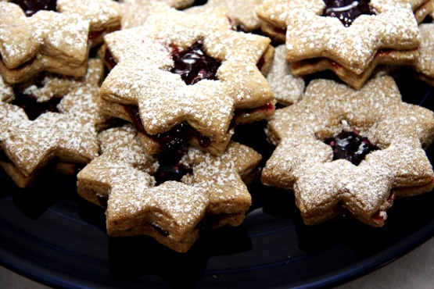

C:\Users\Vint\AppData\Local\Microsoft\Windows\Temporary Internet Files\Content.IE5\QWSO1LID\MC900053374[1].wmf 

C:\Users\Vint\AppData\Local\Microsoft\Windows\Temporary Internet Files\Content.IE5\5YSIQ74W\MC900155490[1].wmf